**SARS-CoV-2 omicron variant modelling**

Bram van Bunnik and Mark Woolhouse, University of Edinburgh, 01/12/21

WORK IN PROGESS

YET TO UNDERGO INTERNAL QUALITY CONTROL

TREAT AS PROVISIONAL - DO NOT CITE

Key points

* 2-strain SIR model generating time line of hospitalised cases during roll-out of booster vaccinations
* Baseline assumptions that omicron is x2 transmissible, equally pathogenic, prior delta infection has no effect, vaccination has no effect on omicron transmissibility
* Impact of omicron limited by herd immunity (against omicron) and impact of booster vaccination on hospitalisation rate.
* In presence of delta only hospital cases fall by approx. 75% over 2 months
* In additional presence of omicron hospital cases start to increase again after approx. 30 days
* At realistic roll-out rates this may **not** lead to a peak in hospitalisations exceeding current levels, but peak size is very sensitive to roll-out rate
* Peak size is also somewhat sensitive to hospitalisation rate of omicron infections in the non-boosted population.
* Sensitivity analysis by FAST (Fourier Amplitude Sensitivity Test) confirms that booster roll-out rate is critical, thus supporting GovUK policy

Model

* 2-strain SIR model with vaccination (Figure 1):
  + S = no booster
  + V = booster vaccinated
  + Ix(Y) = infected with strain x, Y= S, V, R1/R2
  + Rx = recovered with strain x
  + H = hospitalised cases (summed fractions of Ix(Y))
* Baseline model calibrated to basic reproduction number=2.0 for strain 1 at t=0
* Fixed features:
  + Beta for S*I1
  + Beta for V*I1 [set at 0.5xBeta(SI1)]
  + IHR for I1(S)
  + IHR for I1(V)
  + Generation time for strains 1 and 2 [assumed equal]
* Adjustable features:
  + Beta(SI2) relative to beta(SI1)
  + Beta(VI2) relative to beta(SI2)
  + Beta(R1I2) relative to beta(S12)
  + Beta(R2I1) relative to beta(SI2)
  + IHR for I2(S) relative to IHR for I1(S)
  + IHR for I2(V) relative to IHR for I1(V)
  + IHR for I2(R1) relative to IHR for I2(S)
  + IHR for I1(R2) relative to IHR for I1(S)
  + Rate of vaccination
* Starting conditions (t=0):
  + Baseline S=0.48, I1(S)=0.02, I1(V)=0, I2(V)=0 R1=0.3, V=0.2, R2=0, I1(R2)=0
  + Baseline I2(S)= 100 cases
* Outputs:
  + Infection curves from t=0 to t=180
  + Hospitalisation curves from t=0 to t=180
  + Cumulative infections to t=180
  + Cumulative hospitalisations to t=180
  + Peak infections up to t=180
  + Peak hospitalisations up to t=180

Results

* Output for baseline parameters one strain only in Fig 2a
* Output for baseline parameters two strains in Fig 2b
* FAST analysis shown in Fig 3.

FIGURES

Figure 1.

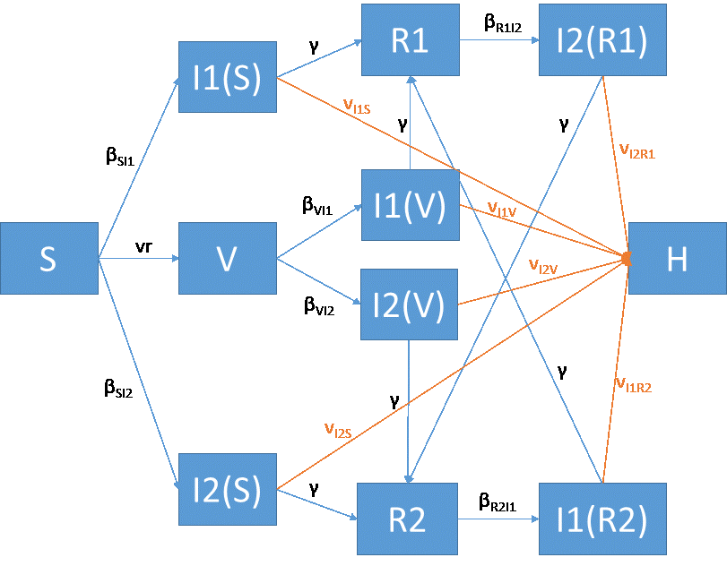

Figure 2a. Baseline output for 1-strain model

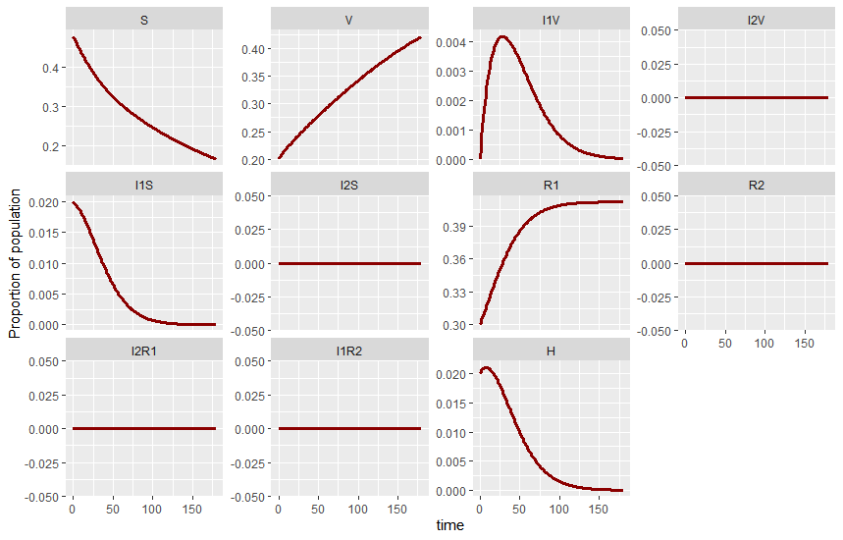

Figure 2b. Baseline output for 2-strain model

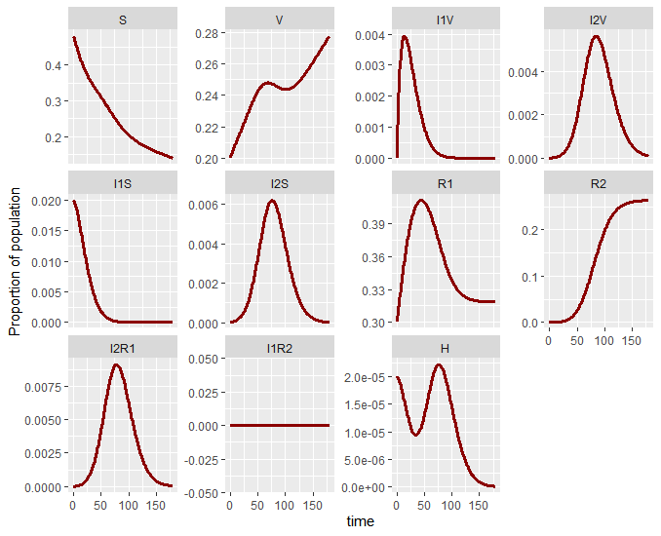

Figure 3. FAST analysis for total hospitalisations for t=0 to t=180. I2_0: initial value of proportion infected with strain 2; R0_2: R0 of strain 2; IHR4: IHR for I2(S); IHR2: IHR for I2(V); vr: vaccination rate; eff2: efficacy of booster against strain 2.

